|  |
| --- |
|  |
| Interest Calculation |
|  |
| Banking Application |
|  |
|  |

|  |
| --- |
|  |

Table of Contents

Functionality include in this project 2

Technology 2

Database 2

Table Details 2

# Functionality include in this project

1. Create Account
2. Balance Update
3. Daily Interest Accrual
4. Bulk Balance Update on Accounts
5. Monthly Interest Update
6. Account Closure

# Technology

1. Java
2. Spring Boot
3. Spring JPA

# Database

1. MySQL Database

# Table Details

1. Account Information Details

Table Name : account

|  |  |  |
| --- | --- | --- |
| **Column Name** | **DataType** | **Allow Null** |
| Identification | bigint | No |
| balance | decimal(10,5) | Yes |
| branch_code | varchar(255) | Yes |
| closing_date | Datetime | Yes |
| first_name | varchar(255) | Yes |
| interest_accrual | decimal(10,5) | Yes |
| interest_rate | decimal(10,5) | Yes |
| last_name | varchar(255) | Yes |
| opening_date | datetime | Yes |

1. Account History Details

Table Name : history

|  |  |  |
| --- | --- | --- |
| **Column Name** | **DataType** | **Allow Null** |
| Identification | bigint | No |
| hist_sequence | bigint | No |
| tso | varchar(255) | Yes |
| eodbalance | decimal(10,5) | Yes |
| lstdate | datetime | Yes |
| monthlyinterest | decimal(10,5) | Yes |
| operation_type | varchar(255) | Yes |

# Swagger Snap shot

URL : <http://localhost:8080//swagger-ui.html>

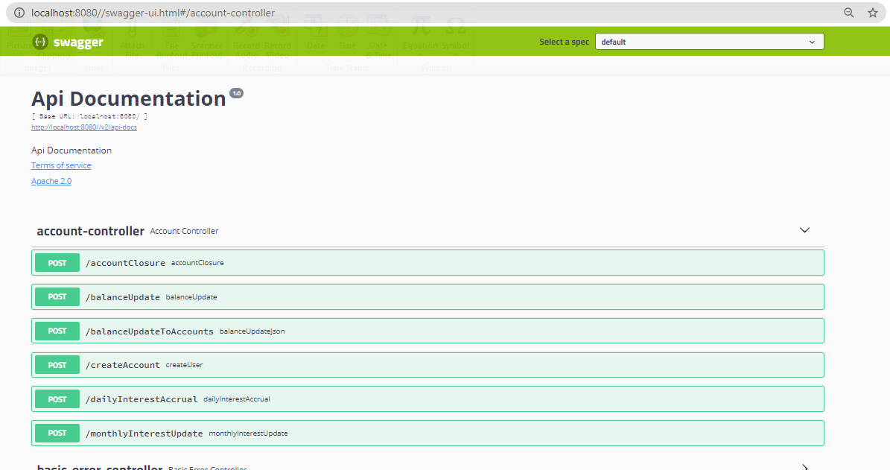

Account Creation

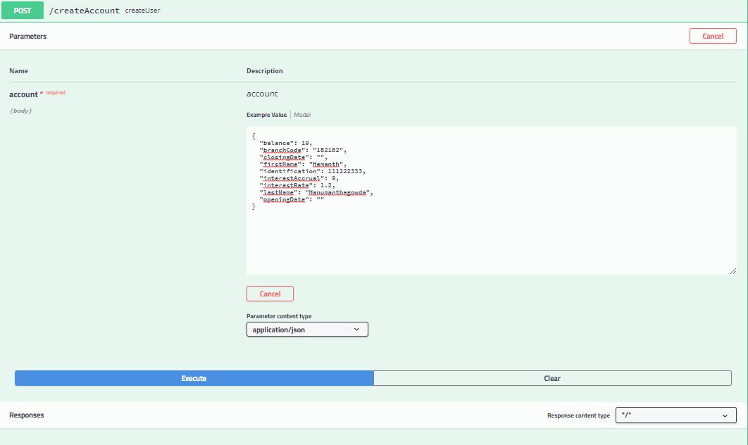

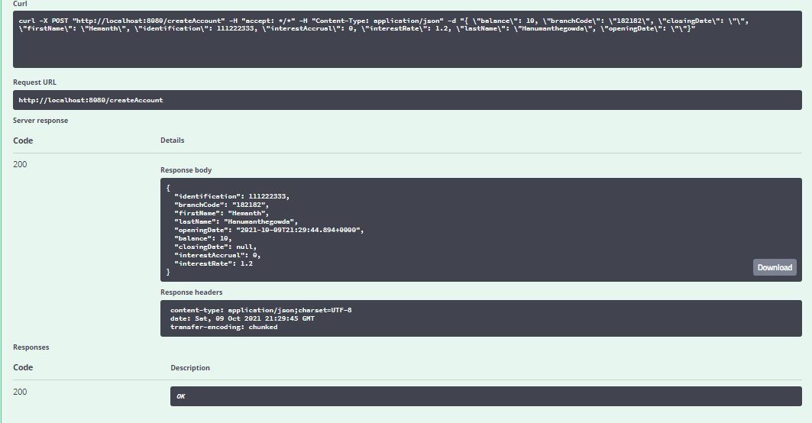

Database Value:

Account Table



Account History



Daily Accrual

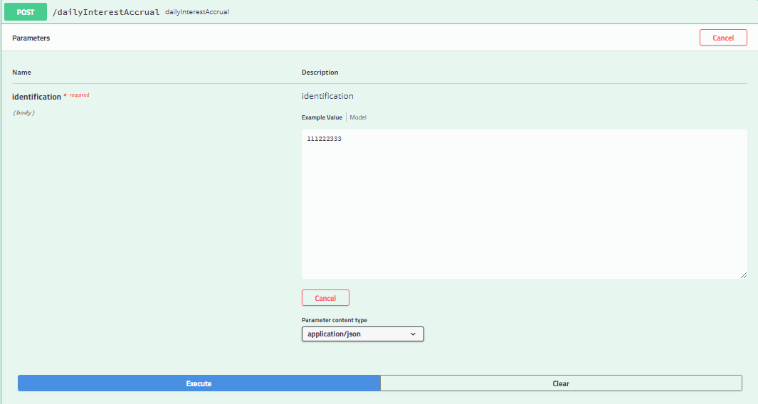

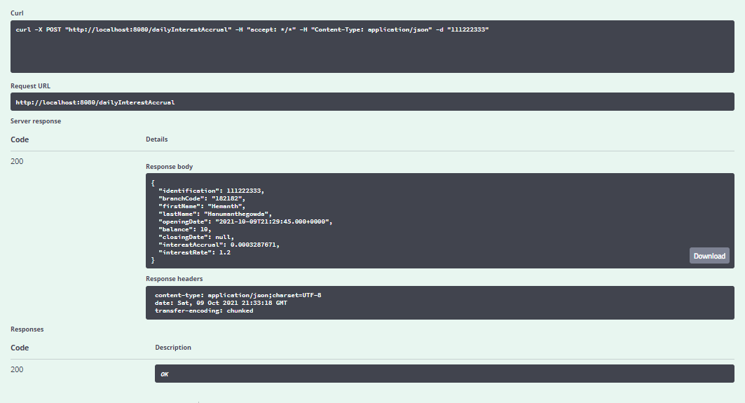



Execute the accrual event again to see the change in daily interest update



Monthly interest accrual event

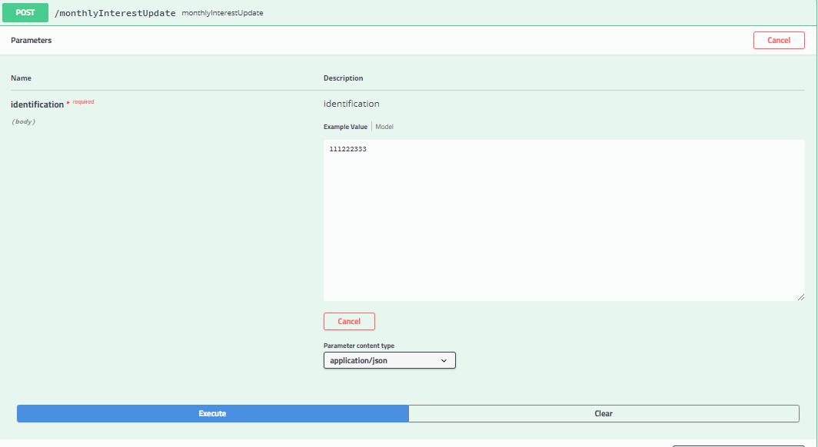

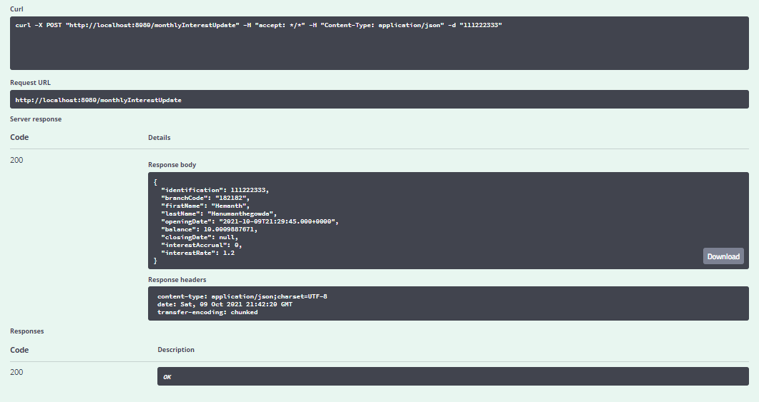



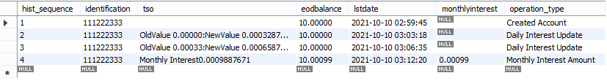

Since interest accrual posted on the account, balance got increase and interest accrual field be zero, corresponding eod balance on history will be updated for latest value.

Account Closure

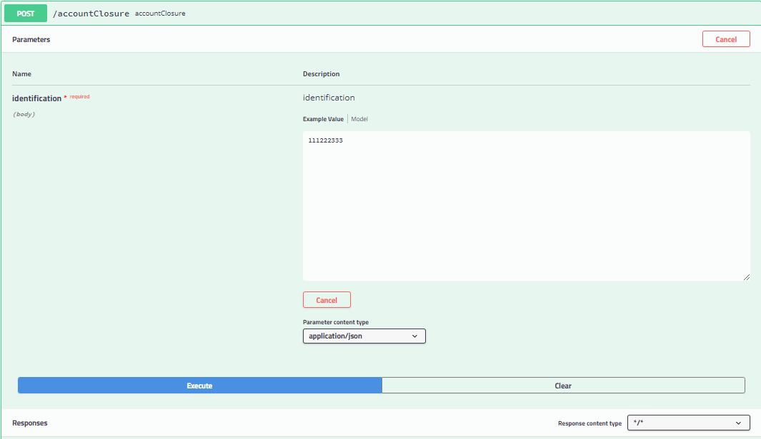

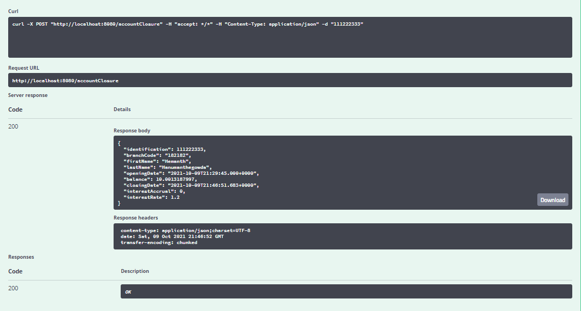



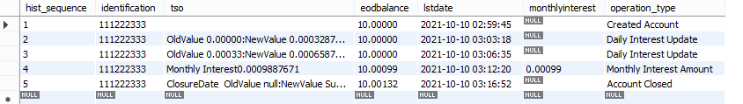

In the above case account is mark for closer, and interest is updated on the account balance.

# Assumptions

Create Account Method :- Account sequence number are not auto generated , manually provided by user

Account History :- Based on the operation type account details are stored in history table

Balance Update Method :- There is no computation on end of the day balance, data provided by bulk balance update are directly updated on the account accounts.

There is no product details for creation of account, basic information are project as an input. like interest rate (no product defined for this product)

# Limitations

No method created for account number generation, if not provided in the input.

No validation applied on the account information

Backed dated amount and interest posting are not performed on the accounts.

No schedules are set for the daily interest and monthly interest amount.

No separate data store for event logs, account details are stored in history table only.

No method or function provided to view history details, those to be view from the database directory .